**VISO SYSTEMS LabTarget**

**User Manual**

Date of creation: 16.12.2021  
Date of last edit: 20.12.2021

*Congratulations on purchasing your new Viso Systems product. Before using this product, please read our Safety Information.*

*This manual contains all the feature operating information and troubleshooting necessary to install and operate your new Viso Systems product. Please review this manual thoroughly to ensure proper installation and operation.*

*For news, Q&A and support at Viso Systems, visit our website at* [*www.visosystems.com*](http://www.visosystems.com)

*Other manuals in this series can be downloaded from* [*www.visosystem.com/manuals*](http://www.visosystem.com/manuals)*. Viso manual are subject to change without notice. Details and may vary from those show.*

# Safety Information

*Warning! This product is not for household use.*

Read this manual before installing and operating the LabTarget, follow the safety warnings listed below, and study all the cautions in the manual.

## Caution Electric Shock 17mmPreventing electric shocks

The LabTarget is power via Ethernet cables. Make sure the powering unit is always grounded.

If the unit or its power supply is in any way damaged, defective, wet, or show signs of overheating, disconnect and contact Viso Service for assistance.

Do not install or use the device outdoors. Do not spray with or immerse in water or any other liquid. Do not remove any covers or attempt to repair the unit. Refer any service to Viso.

## Billedresultat for Laser warningLaser warning

The product contains a red laser (Class 2 laser product, λ = 650 nm, <1 mW, EN 60825-1:2007). Caution: Do not stare directly into the laser beam or mirrored reflections of it.

# Weee symbol 24mmDisposing of this Product

Viso Systems products are supplied in compliance with Directive 2012/19/EU on waste - electrical and electronic equipment (WEEE) together with the RoHS Directive 2011/65/EU with amendments 2015/863. Help preserve the environment! Ensure that this product is recycled at the end of its lifetime. Your supplier can give details of local arrangements for the disposal of Viso Systems products.

# Introduction

## About this document

These guidelines describe the installation process of the LabTarget.

## About the LabTarget

The special Viso accessory “LabTarget” is an laser-based positioning element that is supposed to installed in the ceiling over a Viso goniometer. The unit emits a red, vertical beam cross that is centred in the vertical rotation axis of the goniometer. Hence, the laser beam makes it easy to adjust the photometrical centre of any light source before measurement.

© 2007 Viso Systems ApS, Denmark  
All rights reserved. No part of this manual may be reproduced, in any form or by any means, without permission in writing from Viso Systems ApS, Denmark. Information subject to change without notice. Viso Systems ApS and all affiliated companies disclaim liability for any injury,

# LabTarget Installation Procedure

## Step 1

Install the base plate in the ceiling just above the Viso goniometer. The base plate should be approximately[1] over goniometer rotational center with screws through the three peripheral holes:

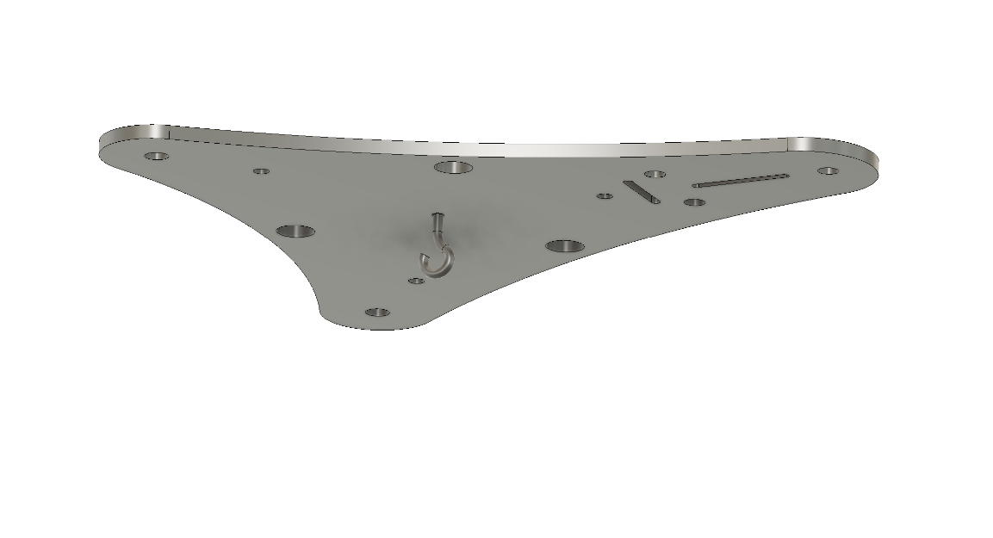

**BasePlate**

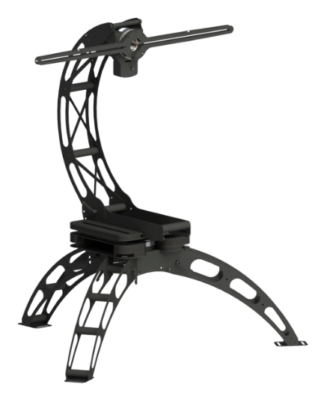

**LabSpion**

## Step 2

Suspend the pendulum from the small hook on the base plate. The pendulum hangs through the hole in the goniometer – the string thus marking the rotational axis of the goniometer. Adjust the string to make the pendulum hang just a few millimeters above floor level.

Make a mark on the floor where the tip of the pendulum points to.

If necessary, move the whole goniometer to the floor position where the string is exactly in the rotational center.

## Step 3

Remove the pendulum and the small hook

## Step 4

Mount the laser module with 3 pcs screws M4x6

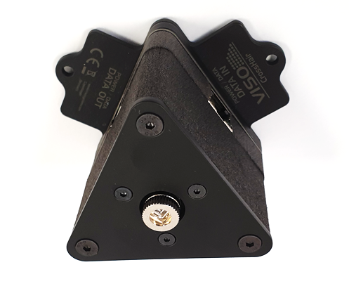

## Step 5

Rotate the module with your fingertips to make one of the laser lines parallel with the photometrical axis (gamma 0):

**Photometrical  
 axis**

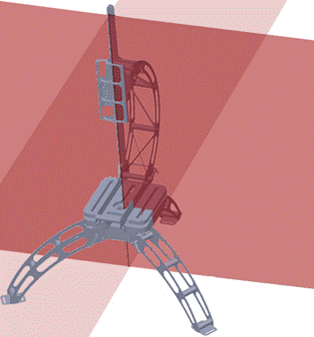

## Step 6

Use an Allen key in the three middle screws to adjust the laser vertically to hit the mark on the floor



## Step 7

Connect the laser module to your system using ethernet cables.

**If you own a LabRail system**, just connect the laser module to the RJ45 plug on the endstop of the Rail (connect to port 1 or port 2, both choices are ok):

If you own a standard **LabSpion/BaseSpion,** Daisy-chain LabTarget with your sensor in this way:

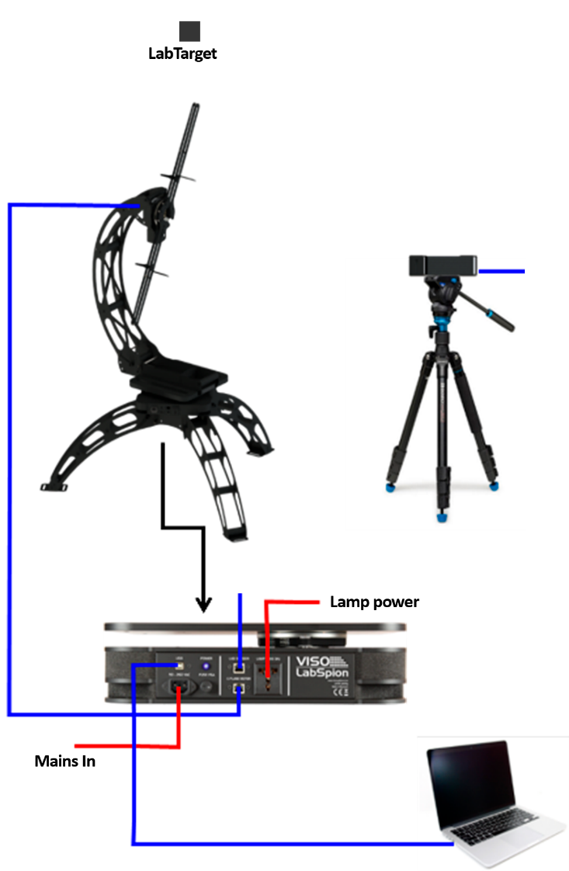

# Technical Specifications

Power and data Via Ethernet RJ45

Dimensions, L*W*H

Materials Powder coated steel housing

Weight

Laser Class Class 2 laser product  
λ = 650 nm, <1 mW, EN 60825-1:2007)

1. If the goniometer is fixed firmly to a table or a floor, mount the pendulum first to ease positioning.